**Prerequisites:**

•         A unique Practice GUID (practiceinfo.UniquePracticeId) and Practice Name (PracticeInfo.PracticeName)

•         Connectivity to an instance of AmazingCharts database

•         Credentials to connect to the DB (Read-only access suffices)

**Setting up Read-Only user**

This is created in SQL by running the below script. In the script, make sure to replace the password noted by “AmazingData” with a unique password that contains upper and lower case characters, numbers, and symbols.

SET XACT_ABORT ON

GO

BEGIN TRANSACTION

DECLARE @userName AS NVARCHAR(50)

DECLARE @password AS NVARCHAR(50)

DECLARE @sql AS NVARCHAR(MAX)

SET @userName = N'popUSER'

SET @password = N'XXXXXXXXXX'

-- Create server level logging

SELECT @sql = N'CREATE LOGIN ' + QUOTENAME(@userName) + ' WITH PASSWORD = '''+@password+''''+ ' , DEFAULT_DATABASE = [AmazingCharts];'

-- Create database user for login

+ 'USE Amazingcharts

CREATE USER ' + QUOTENAME(@userName) + ' FOR LOGIN ' + QUOTENAME(@userName) + ';

USE Codes

CREATE USER ' + QUOTENAME(@userName) + ' FOR LOGIN ' + QUOTENAME(@userName) + ';

USE Meds

CREATE USER ' + QUOTENAME(@userName) + ' FOR LOGIN ' + QUOTENAME(@userName) + ';

USE logs

CREATE USER ' + QUOTENAME(@userName) + ' FOR LOGIN ' + QUOTENAME(@userName) + ';

USE partnertransactions

CREATE USER ' + QUOTENAME(@userName) + ' FOR LOGIN ' + QUOTENAME(@userName) + ';'

-- Add permissions for login

+ 'USE AmazingCharts; EXEC sp_addrolemember db_datareader, ' + @userName + ';

USE Codes; EXEC sp_addrolemember db_datareader, ' + @userName + ';

USE logs; EXEC sp_addrolemember db_datareader, ' + @userName + ';

USE partnertransactions; EXEC sp_addrolemember db_datareader, ' + @userName + ';

USE Meds; EXEC sp_addrolemember db_datareader, ' + @userName + ';'

EXEC sp_executesql @sql;

COMMIT TRANSACTION

GO

**Installation and Configuration:**

1. Create a directory on one of the drives, say C:\program files(x86) and name it acPopHealthAgent

2. Download the acPopulationHealth Data Extraction Agent (DEA) Setup from here and unzip to the above directory: <https://unislinka366.blob.core.windows.net/unislink-file-repo/dea/dea-2.19.0-ac-10-acprod.zip>

3. Navigate to the directory and click “setup” file.

4. Follow the wizard to complete the setup and schedule the agent as show below

4a. Enter in the info on the first screen as prompted. The username will be a read only user that is created in SQL. You can leave the port blank. Once entered click on test connection. You will be given a confirmation that it can connect then click next.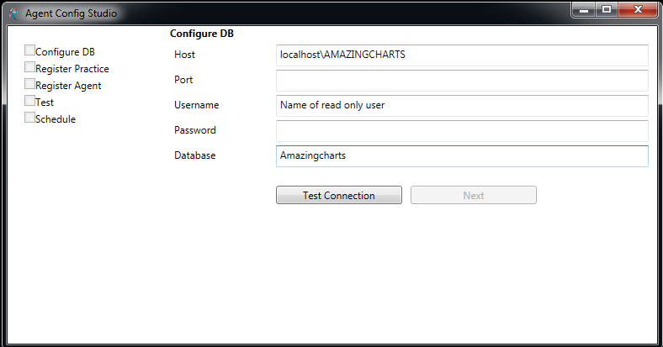

4b. Verify that this information matches the practice name and the practice GUID from the systemsettings.xml file. Then click register and then next.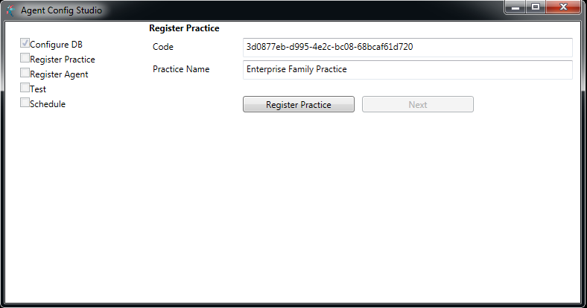

4c. again, verify this information is correct and click register and then next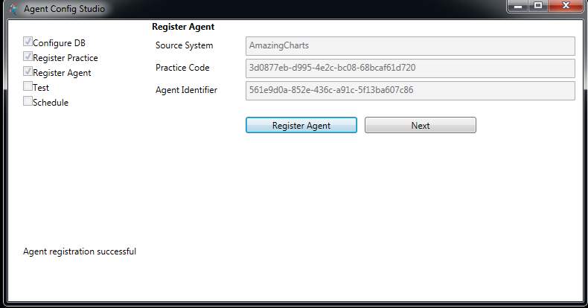

4d. Click on the test agent button and make sure you see test succeeded and then click next.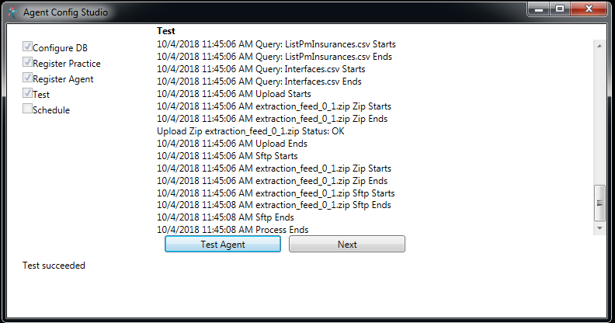

4e. set the time that the agent task will run. This task will run every 24 hours at the entered time. Click on schedule and then click agent.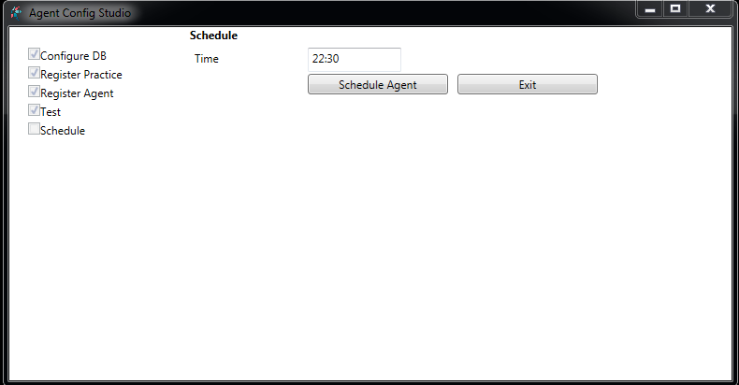

**Post Installation:**

5. Now update the meds database URLs table with the CTQA url so that the application redirects to CTQA as opposed to UNIS DEMO. This can be done by running the following Script

use meds

update urls

set URLLocation = 'https://demo.unislink.com/amazing/#/page/login?tk={0}&lp=QDSH'

where URLId = 'UnisLinkCqmDashboardUrl'

update URLS

set urllocation = 'https://demo.unislink.com/amazing/#/page/login?tk={0}&lp=PTVW&mrn={1}'

where urlid = 'UnisLinkPatientViewUrl'

update URLS

set urllocation = 'https://demo.unislink.com/amazing/#/page/login?tk={0}&lp=PDSH'

where urlid = 'UnisLinkPopHealthUrl'

update urls

set URLLocation = 'https://demo.unislink.com/amazing/api/practiceaccount/register'

where urlid = 'UnisLinkPracticeRegisterUrl'

6. Open Windows Task Scheduler, locate the acPopulationHealth Data Extraction Agent job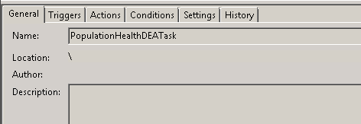

 6a. Double click on the task or right click and select properties to open the properties of the task. Change the default option “run only when user is logged in” to “run whether user is logged in or not.

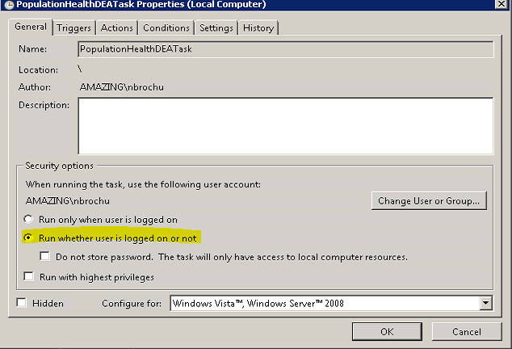

6b. Save the changes, and kick off the task once, and ensure that it completes.

**Validation:**

1. The DE Agent has validation built-in and finishing the setup with scheduling is proof that it is setup properly.

2. Open AmazingCharts. Click on one of the CQM / PopulationHealth Menu items and navigate to acPopulationHealth window. Right-click on the web page, click “Properties” and verify that the URL is pointing to <https://qa-cqm.caretrackertest.com/amazing/>